“Youth in Action for Wellness: Strategies to Make Positive Changes”
Please join us for the IHS Health Promotion/Disease Prevention Public Health Adobeconnect Teleconference on Thursday, September 13, 2012 at 1:00 p.m. – 2:00 p.m. (Eastern Time).
URL: | http://ihs.adobeconnect.com/r1m69542uzb/
Conference Number(s): | United States: +18008320736
MeetingOne Conference Room Number: | 6384762
Save to your Outlook Calendar: ..\..\..\..\Desktop\Youth in Action for Wellness Strategies to Make Positive Changes Webinar.ics

Objectives:
1. The participants will be able to identify 2 prevention strategies that were successfully implemented in the AI/AN communities.
2. The participants will learn how the Gang Prevention through Intervention, Prevention and Suppression model can assist in addressing gang violence.

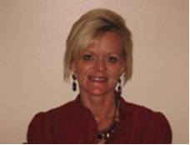
Presenters:
Taking Back our Communities: Gang Prevention Strategies for Tribal Communities

Janelle Trottier, MSW, LCSW
Aberdeen Area Indian Health Service

The Healthy Community Model in Action: The Pueblo of Santa Ana Youth Health and Fitness Project

Alina Potrzebowski, BA
Youth Health and Fitness Coordinator
Pueblo of Santa Ana Community Wellness Program

Please sign in at least 5-10 minutes before the presentation. No registration required.

