Smoky Air from Fires

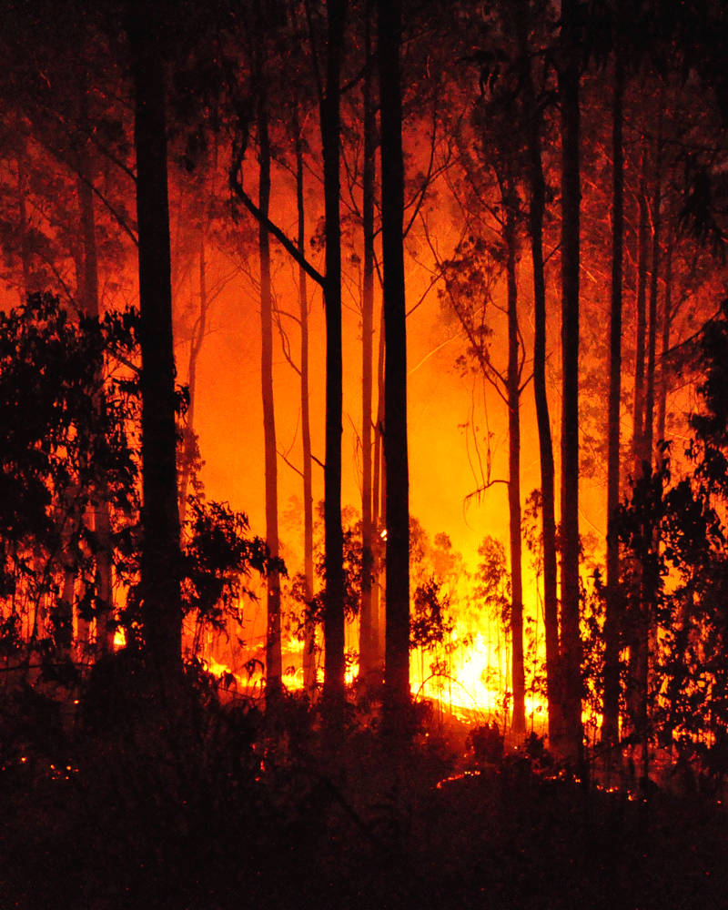
The Five Most Important Tips to Protect Yourself and Your Family

Pay attention to air quality reports on radio, TV or in the newspaper and follow instructions about outdoor activities and safety measures.
- If you are advised to stay indoors, keep indoor air as clean as possible. Keep windows and doors closed. If you don’t have an air conditioner and it is too hot with the windows closed, consider visiting the mall, the library, or a place with air conditioning for temporary relief.
- Keep car windows closed while driving and run the air conditioner on the inside air setting.
- Drink plenty of water.
- Follow your doctor’s advice about medicines and about managing your health conditions. Call your doctor if your symptoms worsen. Keep at least a five day supply of medication on hand.

Important to Remember
- Children, the elderly, pregnant women and people with lung and heart problems are more likely to be affected by health threats from smoke.
- Dust masks are not effective against wildfire smoke.

Air Conditioning and Swamp Cooler Information
Run an air conditioner if you have one, but keep any fresh air intake closed and filter clean to prevent outdoor smoke from getting inside. If you see heavy, visible smoke outside, do not use a swamp cooler.

Wildfire Evacuation
If you are evacuated, be prepared to be away from your home for an undetermined amount of time. Be sure to take:
- Vital records (birth certificates, marriage license, etc.)
- Medications and prescription eyeglasses
- Pets
Drive carefully when visibility is reduced because of smoke, and remember that fire crews are working hard to put out fires. Be courteous and do not go sight-seeing in evacuated areas.

<insert organization name here>

