U.S. NUTRITION LABELING - EVOLVING PROCESS
Similar to the sneak peek that a movie trailers provides, nutrition labeling give information related to healthy diets and dietary recommendations. Unlike movie trailers starting in 1913, mandated nutrition labels are relatively recent. As advances in science and nutrition, and changes in consumer behavior the need for nutrition labels will continue to evolve. The 2016 approved changes to nutrition labeling is the first significant since the 1990, when nutrition labels became mandatory. Reason for the changes include 1970s and ’80s nutrition data was still being used, changes in consumers eating habits, increased portion sizes. Experts have predicted that the 2015 approved changes to the nutrition labels may result in major reformulations of some of the 800,000 food products. In part this prediction is contributed to concerns by companies that products will be less appealing under the new rules. It has been suggested that than 77 percent of Americans reported using nutrition labels when shopping. While reducing things like added sugars may be a health benefit to consumers, doing so can often be complex. For example, manufactures often increase the amount of sugar in a product to offset bitterness when trying to increase the amount of whole grains in a product.

An Abbreviated Timeline
1938: The FDA regulations prohibited the explicit discussion of disease or health on food labels as part of the Federal Food, Drug, and Cosmetic Act. At this time, current links between diet and disease had yet to be established or proven. The intent was to prevent misleading and potentially harmful claims.

1941 to 1966: When manufactures included information on the calorie or sodium content on some food labels, the foods were considered by the FDA to be for “special dietary uses”. Intended to meet particular dietary needs caused by physical, pathological, or other conditions. Overall, prior to the mid-1960s, there was little information on food labels to identify the nutrient contents.

1969: The White House Conference on Food, Nutrition and Health was held in response to consumers requesting information that would help them understand the products because of the increasing numbers of processed foods being sold.
Developing a system for identifying nutritional qualities of food was being considered by the FDA. To enable consumers to follow recommended dietary guidelines manufacturer were to be encouraged to provide truthful nutritional information about his products.

1973: Scientific knowledge about the relationship of diet and health grew rapidly. This lead to consumers wanting more information on food labels, in particular on the labels of processed and packaged foods. The FDA’s finalized their 1972 proposed regulations specifying nutrition information on packaged foods. This specified that when nutrition labeling was on FDA-regulated foods, the number of calories; grams of protein, carbohydrate, and fat; and the percent of the U.S. RDA was to be included.

1978: The vast majority of comments gathered at hearings held on information on food labeling, favored mandatory nutrition labeling, and changes to the format to make it more useful. The widespread use of ambiguous claims on labels and in advertising resulted in allegations that charges that the U.S. government was tolerating claims that were “at best confusing and at worst deceptive economically and potentially harmful”.

1984: The FDA’s 1938 restriction on food labels including disease or health claims was challenged by Kellogg Company working in cooperation with the National Cancer Institute, interested in highlighting the link between high-fiber consumption and possible reduction in the risk of certain cancers.

1987: The FDA proposed changes to its policy, which would permit health claims on food labeling if meeting certain criteria, generated meaningful and conflicting comments. The FDA withdrew its original proposal, and in 1990 published a new proposal that defined appropriate health claims more narrowly and set new criteria to be met before allowing a claim. Responding to both consumers and the food industry, rulemaking was initiated rulemaking to provide more flexibility in making claims on foods that could be useful in reducing or maintaining body weight or calorie intake, establish policies concerning fortification of foods, include sodium content, allow claims about sodium and cholesterol content, and to allow for food labeling experiments, such as experiments on supermarket shelf labeling.

1990: The passage for the Nutrition Labeling and Education Act (NLEA) (Public Law 101-535), signed on November 8th by George H. W. Bush, is credited to members of congress becoming aware of consumer and industry interest in the subject. This law required that all nutrient content and health claims meet FDA regulations. Earlier in the year, the FDA published proposed rules for the mandatory nutrition labeling of almost all packaged foods. The NLEA pertains only to those labels of food products regulated by FDA, which has label authority over the majority of foods. Supporting the passage for the NLEA, was the Institute of Medicine (IOM) report, Nutrition Labeling: Issues and Directions for the 1990s, was released in September. It recommended that FDA and FSIS adopt regulations to institute mandatory and uniform nutrition labeling for almost all packaged foods. This included recommendations on various aspects of nutrition labeling, including content and presentation of information, in order to meet the recommendations of The Surgeon General’s Report on Nutrition and Health (HHS, 1988) and the NRC’s report Diet and Health: Implications for Reducing Chronic Disease Risk (NRC, 1989a).

1991-1992: The FDA proposed additional requirements in order to achieve three things, i) to clear up confusion that had surrounded nutrition labeling for years, ii) to help consumers choose healthier diets, and iii) to give food companies an incentive to improve the nutritional qualities of their products.

1993: Final regulations were published on January 6, mandating nutrition labeling in the form of a Nutrition Facts panel on most packaged foods. Nutrients to be listed on nutrition labels included calories, calories from fat, total fat, saturated fat, cholesterol, sodium, total carbohydrate, dietary fiber, sugars, protein, vitamins A and C, calcium, and iron. Exemptions were allowed for foods that were insignificant sources of calories or nutrients, foods shipped in bulk for further processing, restaurant foods, foods manufactured by some small businesses, medical foods, and infant formula (the latter having other specific rules for labeling). Comments received by FDA showed a lack of consensus on a definition for the term “complex carbohydrates” as it related to physiological effects, health benefits, or dietary guidance and resulted in complex carbohydrates not being included in the allowed list of nutrients. As early as
1991 the FDA was receiving opposing comments and concerns around sugar and trans fats, in regard to additional changes to nutrition labels.

2003: The FDA issued the final rule on the 1999 proposal to modify the Nutrition Facts panel to include trans fats on food products they regulated. This required trans fats to be listed on a separate line immediately under saturated fat, whenever present in amounts of 0.5 g or more per serving. And, that trans fats must be listed if health claims are made.

2007: The FDA issued an advance notice of proposed rulemaking asking for comment on which daily reference values (DRVs) the agency should use to calculate the percent of daily value in the Nutrition Facts panel and whether certain nutrients should be added or removed from the labels. This was supported by an Institute of Medicine 2003 report on DRVs, based largely on recommendations from The Surgeon General’s Report on Nutrition and Health (HHS, 1988), the NRC’s report Diet and Health: Implications for Reducing Chronic Disease Risk (NRC, 1989a), and the National Cholesterol Education Program’s “Report of the Expert Panel on Population Strategies for Blood Cholesterol Reduction” (NIH, 1990). After final content was determined, the FDA worked with graphic experts to design the label, taking into account research on comprehension, legibility, and literacy.

2016: The FDA2014 proposed changes to the nutrition labels was approved, with calorie counts to be shown in large bold print, and portion sizes that reflect how much Americans actually eat. In addition to added sugars, new nutrients that must be declared include Vitamin D, potassium. The new label requirements are the result to the FDA for years negotiating with the food industry, other government agencies and consumer groups on what changes to make.
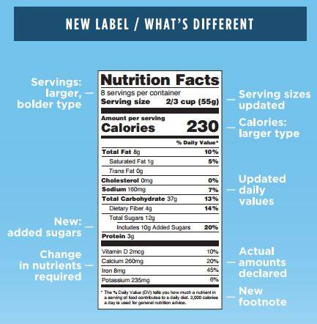
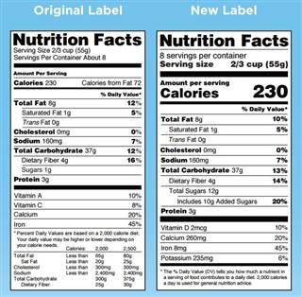
2018: Most food manufacturers will be required by July to use the new label. Producers with less than $10 million in annual food sales will have an additional year to comply.

