Steps | Visual | Description
Step 1 | 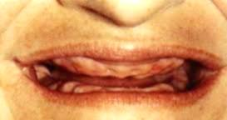 | Remove all bad teeth: This step may take several appointments depending on how many teeth are present. Occasionally, an additional step is required to smooth the ridges to make wearing your new dentures comfortable. After all teeth are removed, the ridges needs time to heal and be able to change shape.
Step 2 | 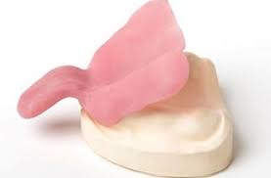 | Initial impressions: After your ridges have had time to start the healing process, we will take the Initial Impressions so that we can make study models. These models will help us build a denture that is custom to your face and features.
Step 3 | 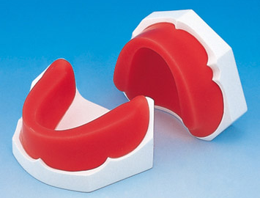  WAX | Wax Rims and Final Impression: In this step, there is a plastic base with a block of wax on it. We take a final impression with this base. We will shape the wax in your mouth so that the dental laboratory knows where to place the denture teeth.
Step 4 | 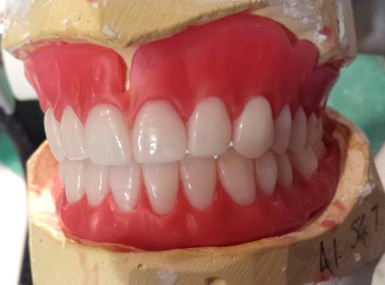  WAX | Esthetic Wax Try-In: In this step, the dental laboratory has placed the denture teeth in wax on the base. We try it in your mouth to make sure it looks and functions correctly. It is easy to change things about the denture at this point because the teeth are still in wax. Sometimes this step can take more than one appointment. Once the changes are made to your satisfaction, we send it into the laboratory to process the denture in hard acrylic.
Step 5 | 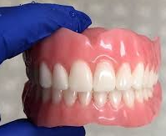  ACRYLIC | Denture Delivery: At this step, we try the completed denture from the laboratory in your mouth and check for good fit, function, and esthetic appearance. There may be a few minor adjustments at this step to make your denture more comfortable. Then you get to take your denture home!
Step 6 |  | Denture adjustments: It may take a few more appointments of adjusting the inside of the denture or the teeth to make it more comfortable for eating and speaking. This is a normal part of adjusting to a new denture. Always ask any questions you have to your dentist.
The Dulce Dental Clinic Denture Appointment Steps
**It is important to visit the dentist once a year for a checkup after you receive your dentures to check for sore spots, check for changes to the fit of your denture, and to make sure your gums are healthy.

