The [Name of Clinic] Dental Clinic
COMPLETE DENTURES
Home Care Instructions

About your new dentures
You have just received your new dentures. You must be aware that artificial teeth are not like natural teeth and will require a period of adjustment. This period of adjustment varies in length with each patient, but as you learn how to use your dentures, they will become more comfortable for eating and speaking.
Denture sores
New dentures often cause sore areas in the mouth. The dentist must adjust the dentures to allow these sores to heal. If the dentures are terribly uncomfortable, remove them from the mouth and leave them in water. You will need to wear the dentures the day you are coming to see the dentist, unless the mouth is quite sore. It is normal to need a few adjustments to your dentures after you receive them.

Adjusting to new dentures
Learning to eat and speak with your new dentures, even for experienced denture wearers, is a difficult situation.
Increased saliva is obvious from the start. In three to four weeks your salivary flow will return to normal.
Speech is also affected. Your tongue may feel restricted at first. It needs time to adjust to the shape of the new denture and learn how to clearly say such letter as “s” “sh” and “b”. Practice when you are alone. Read the newspaper out loud or “talk back” to the television. In the beginning the effort seems great, but it will soon become a natural part of your daily life.
Eating with dentures
The day you get your new dentures you may be tempted to go out and eat something special to celebrate. Even dentures that are very well-fitting can bite and chew with less than 1/3 the efficiency of natural teeth. Go slowly! Start with softer foods such as noodles, stews, and casseroles. Everyday try something new.
With natural teeth, you tend to chew on only one side of your mouth at a time—but with dentures you need to balance the load by chewing on both sides at the same time. This is a difficult task to learn and will take great concentration at meal time.
Biting into food, such as a sandwich, is often very difficult and may be easier using the corners of the mouth- not in the front. Many people find it easier to eat open face sandwiches which can be cut with a knife and fork. Sometimes, when biting, the back of the upper denture can be supported by rolling your tongue and pressing the back portion of the denture. After the food is bitten off, relax your tongue and chew.
The following food will be extremely difficult to eat with full dentures:
- Corn on the cob
- Spare ribs
- Tough meats
- Bulky rolls/submarine sandwiches
- Lettuce
- Apples
Hard food such as nuts should be avoided since they can cause gum damage when small pieces get under the denture.
Chewing sticky foods, such as gum and caramels, will dislodge the dentures.
As you learn to use your new dentures, you will discover what foods you can include in your diet and which you cannot.

Cleaning and caring for dentures
Your new dentures must be kept out of the mouth in water for at least eight hours each night. This allows your gums time to “breathe” and recover from the pressure of wearing the dentures. Remember: You don’t wear shoes to bed, and you shouldn’t wear your dentures to bed either!
After removing your dentures, start by brushing your gums, tongue, and roof of the mouth. This will remove plaque, stimulate circulation and reduce the incidence of severe bad breath.
As with your natural teeth, plaque forms on the dentures. This must be removed by brushing the inside and outside of the dentures. Always clean your denture over a sink filled with water or a large folded towel. Dentures will break if they drop onto a hard surface such as the bathroom floor or sink.
Using denture toothpaste can be helpful. Do not use normal toothpaste as it can be too grainy for dentures and may cause micro-abrasions on the surface of the dentures where plaque can grow.
After brushing your dentures, place them in a container with water and add either a denture cleansing tablet (such as Polydent or Fixodent) or a teaspoon of peroxide and let it soak overnight. Dried out dentures can crack and warp. Denture cleanser tablet will remove only large food debris and provide a mild bleaching effect. Tablets should be used in addition to brushing, but not as a replacement!
If unsightly white chalky deposits develop on the sides of the dentures, soak your dentures overnight at room temperate in white vinegar. This should soften the deposits and allow you to brush them off.

Dry mouth
Many patients use medication which dry the mouth. Drugs for high blood pressure, antidepressants, lithium, and sedatives are some medicines which decrease saliva flow. If there is too little fluid in the mouth, the dentures can become uncomfortable to wear. You may feel as if your lips stick to the teeth. It is recommended to use denture adhesives to keep tissues moist and to add suction and lubrication for the denture. This will help protect the tissue from being rubbed harshly by the denture.

Dentures adhesives
Some people have a mouth which is poorly shaped for wearing dentures.
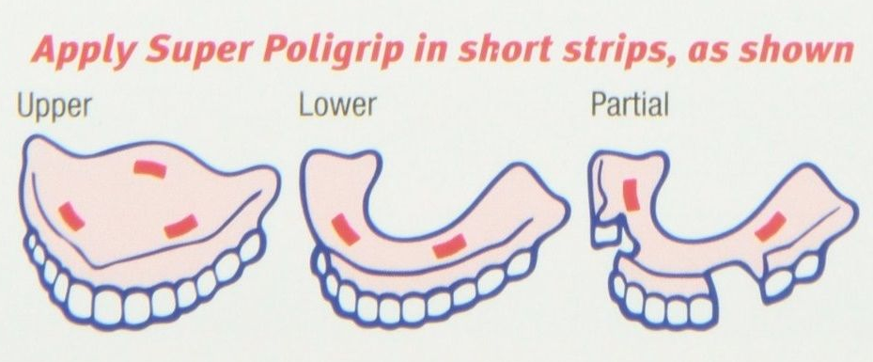
Perhaps the tongue is enlarged or the bone and gums have shrunk. Many of these patients need to use a denture adhesive to aid retention. Powder adhesives are often best suited to a well-adapted denture, while paste style adhesives work better in ill-fitting dentures. Start off with only a little adhesive in the deepest parts of the denture (see picture), and try many different brands. Each person’s saliva reacts differently with each brand of adhesive. Adhesives can be difficult to remove from the denture and off your skin.
You may find that warm water and wash cloth will often speed the cleaning time.
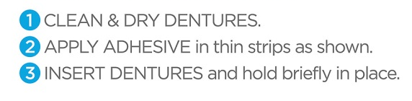
If you have any questions, remember to ask the dentist at your next visit.
Denture Relines
Over time, the oral tissues covered by dentures will tend to shrink, while the dentures remain the same. You will experience loosening of the dentures when this occurs. This can be remedied by adding plastic inside the denture to re-establish an intimate contact between the denture and the tissues—this is called a denture reline. If you feel like your denture is loose or baggy, consult your dentist about a denture reline procedure.

Broken Dentures
The only permanent fix for a denture that is broken in half is a procedure called “denture re-base”. This requires your dentures to be sent to a dental lab for a few weeks. Alternatively, at some clinics, a temporary denture can sometimes be constructed from the broken pieces of your denture. This temporary denture can last 6-8 months while a new denture is being constructed.
Broken or missing teeth can often be added back to a denture at the dental clinic (if they have the supplies available) within 1-2 days.
If your denture is broken, call us to schedule an appointment.

Annual exams
Denture wearers need to see the dentist every year for examination and evaluation.
Chronic denture problems often cause no pain and denture users learn unconsciously how to cope with ill-fitting dentures. Changes in the bone and gum support can happen. As these changes occur, the dentures will develop an imperceptible rocking motion that will act like a hammer against the tissue, accelerating further tissue changes. Bone loss can proceed to the point that the patient becomes unable to wear any denture comfortably. A yearly check-up will allow the dentist to determine the extent of bone loss and the resulting fit of the dentures. The dentist will also examine the entire oral cavity for changes in the tongue, cheeks, and floor of the mouth.
Remember, even with proper care, most complete dentures will only fit and function well for 5-7 years.

Contact us
If you have any questions, feel free to contact us (XXX) XXX-XXXX.

