At this point before we get the G Codes Modifiers loaded in RPMS we could capture it this data 2 ways
Modifiers add this data object at the end of each Physical Therapy Note
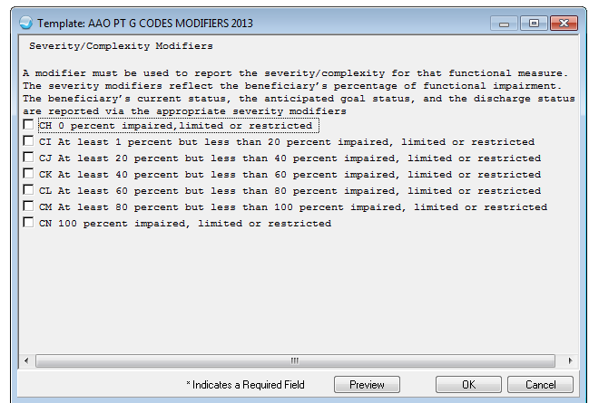
2. Have the PT providers edit the narrative on the G Code Pick list and Add Modifiers manually. Do we have a PT in the Aberdeen Area that can review this with us? We might be able to make a Pick list with all the modifiers preloaded as text – put would need a subject matter expert to help with this.
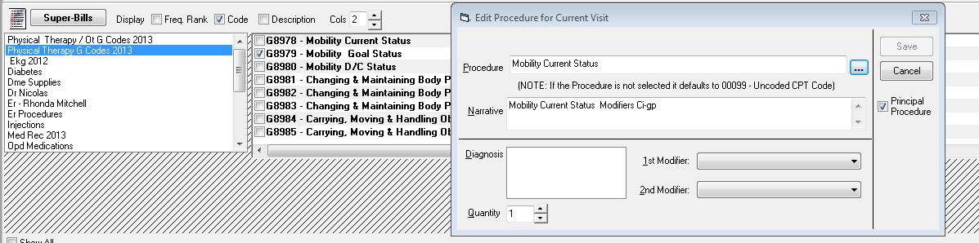
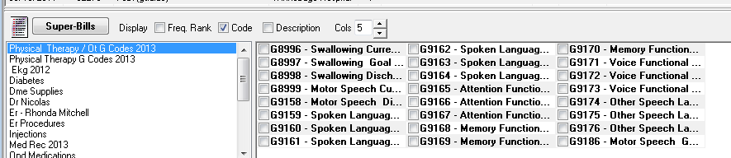
Reference: Preparing for Therapy Required Functional Reporting Implementation in CY 2013 ( December 2012)
http://www.cms.gov/Outreach-and-Education/Outreach/NPC/Downloads/FunctionalReportingNPC.pdf
MLN Matters – Implementing the Claim based Data Collection Requirement for Outpatient Therapy Services – Section 3005 (g)
http://www.cms.gov/Outreach-and-Education/Medicare-Learning-Network-MLN/MLNMattersArticles/Downloads/MM8005.pdf

