 | Facility |  | OCE File# |  | Title of Activity
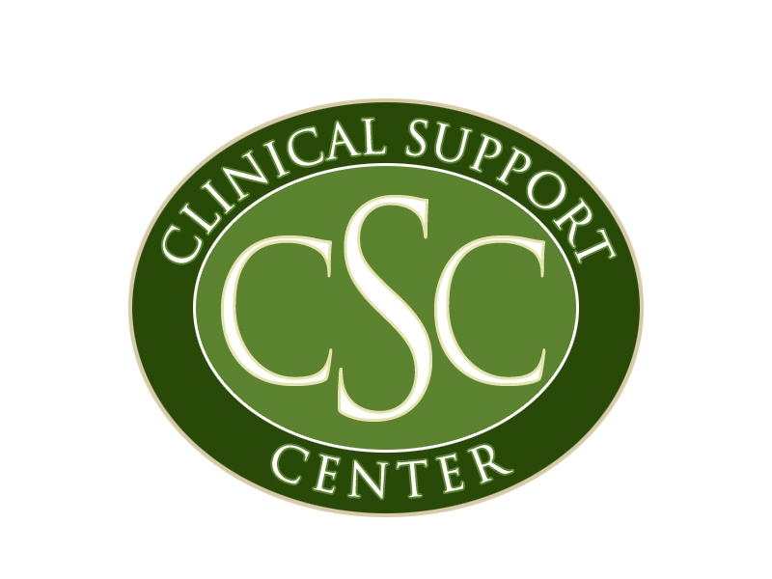
INDIAN HEALTH SERVICE
Clinical Support Center
Office of Continuing Education
40 North Central Avenue, Suite 780, Phoenix, AZ 85004

PHYSICIAN TEACHING CREDIT REQUEST FORM

Title of Presentation:
Date of Presentation: |  |  |  | Time: |  | to
Presenter’s Information:
 | Name & Degree:
 | Job Title:
 | Work Site:
 | Address:
 | Phone:
 | Email:

ACCREDITATION:

The Indian Health Service (IHS) Clinical Support Center is accredited by the Accreditation Council for Continuing Medical Education (ACCME) to provide continuing medical education for physicians.

The IHS Clinical Support Center awards the above presenter with hours of AMA PRA Category 1 Credit™ for teaching as described above.

NOTE: A presenter may receive up to 2 hours of AMA PRA Category 1 Credit™ for each hour of teaching in a Category 1 activity. Physician faculty may not claim credit as a participant for their own presentations; however, they may claim credit for other segments they attend as a participant at a certified live activity. A physician may claim AMA PRA Category 2 Credit™ for any teaching for which they did not receive AMA PRA Category 1 Credit™ for teaching.

________________________________
Dora Bradley, MPH, RN
Director, Office of Continuing Education

*Teaching credits are not officially recorded on your cumulative transcript; please keep all copies of teaching credit certificates in your personal file.

