EVIDENCE BASED PRACTICE TUTORIAL
(EXCERPTS FROM THE NIH RESOURCE TRAINING MANUAL by Judith Welsh, RN, MLS and MAKING THE CASE: WHY EVIDENCE BASED PRACTICE? by Gwenyth R. Wallen,, PhD, RN)

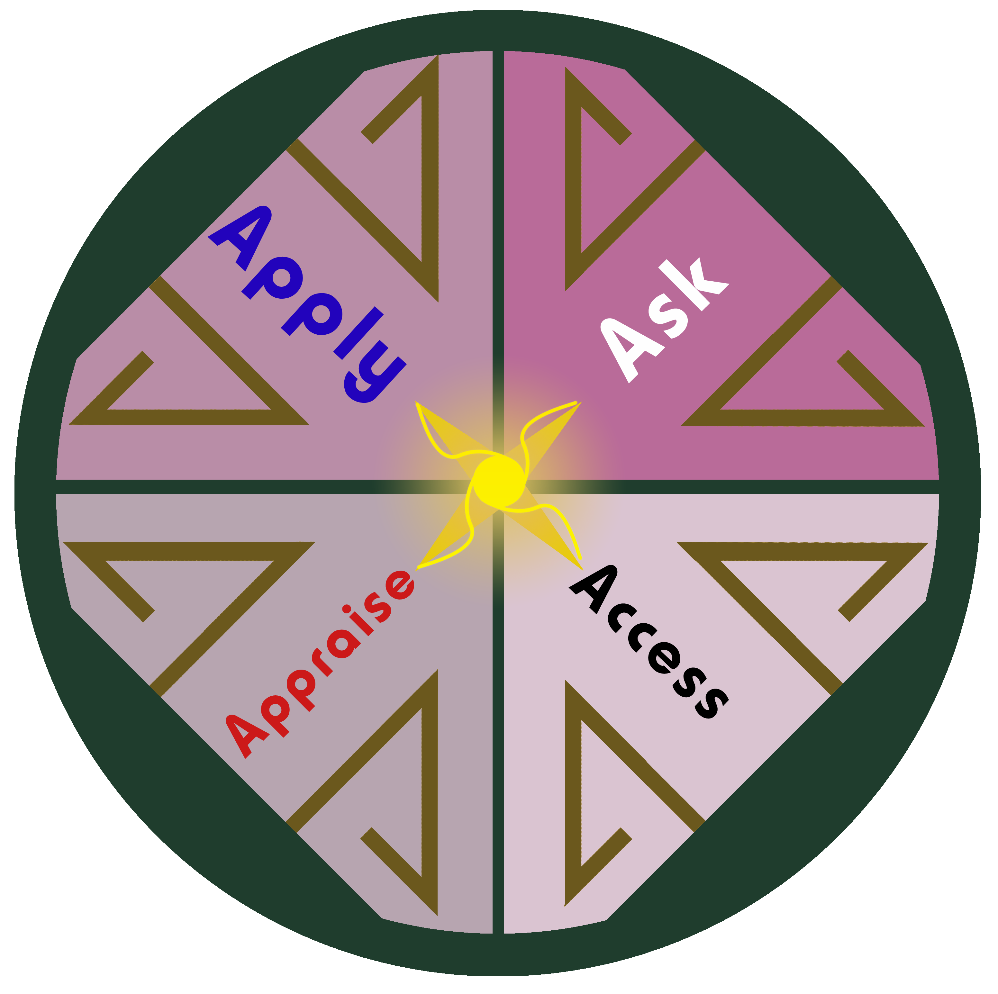

WHAT IS EVIDENCE BASED PRACTICE (EBP)?
Evidence based practice is the conscientious use of current best evidence in making decisions about patient care (Sackett, Straus, Richardson, Rosenberg, & Hayes, 2000). It is a problem solving approach to clinical practice that integrates:
- A systematic search for and critical appraisal of the most relevant evidence to answer a burning clinical question
- One’s own in clinical experience
- Patient preference and values

WHY PRACTICE EBP?
Unfortunately, a great deal of research reported in journal articles is poorly done, poorly analyzed or both, and thus is not valid. A great deal of research is also irrelevant to our patients and practices. Making decisions is a fact of life for nurses. It’s what the nursing process is all about. But we need to know that the decisions we make are sound and based on best evidence. In fact, the ANA has put forth a statement to that effect: “Nurses have a mandate to measure the end results of their care and to improve the results over time.”
FIVE STEPS OF EVIDENCE BASED PRACTICE
- Ask the burning clinical question
Sample burning clinical question:
In nurses, how effective is magnet status versus non-magnet status in improving job satisfaction, recruitment, and retention?
- Collect the most relevant and best evidence
  - The search for best evidence should first begin with systematic reviews or meta-analyses and evidence-based clinical practice guidelines
What is a systematic review? It is a summary of evidence on a particular topic, typically by an expert or expert panel that uses a rigorous process for identifying, appraising, and synthesizing studies to answer a specific clinical question. Conclusions are then drawn about the data gathered through this process. Using a rigorous process of well-defined, preset criteria select studies for inclusion in the review, bias is overcome, and results are more credible.
  - If systematic reviews or evidence-based guidelines are not available, proceed to randomized controlled trials
  - If randomized controlled trials are not available, continue to other types of studies that generate evidence to guide decision making
- Critically appraise the evidence
- Integrate all evidence with one’s clinical expertise, patient preferences, and values in making a practice decision or change.
- Evaluate the practice decision or change

INTEGRATING EBP INTO YOUR PRACTICE
- Try questioning the norm
- Challenge the “way we have always done it”
- Speak DATA
- See one—Do one—Teach One

IGNITING THE SPIRIT OF INQUIRY
- EBP rounds
- Burning clinical question box
- Develop EBP Teams
WHERE TO SEARCH FOR THE BEST EVIDENCE
Cochrane Library
PubMed
CINAHL (Cumulative Index to Nursing and Allied Health Information)
To access all these above sites, go to the Health Services Research (HSR) Library @
http://hsrl.nihlibrary.nih.gov/
To access the Cochrane Library or CINAHL, click on the above link, click on “Research Tools” select “Databases” then choose your database. Enter your search criteria.
To access PubMed, go to the above link and click on “PubMed” under “Quick Links” on the left-hand side. Enter your search criteria.
Summary of these sites:
The Cochrane Library:
- Contains high-quality, independent evidence to inform health care decision-making
- Includes reliable evidence from Cochrane and other systematic reviews, clinical trials, and more
- Reviews bring you the combined results of the world’s best medical research studies
- Recognized as the gold standard in evidence-based health care
PubMed:
- Covers the fields of medicine, nursing, dentistry, veterinary medicine, the health care system, and the preclinical sciences
- Contains bibliographic citations and author abstracts from more than 5,000 biomedical journals published in the United States and 80 other countries
- Contains over 15 million citations dating back to the mid-1950’s
CINAHL:
- Premier database of journal articles covering nursing and allied health
- Includes publications from the American Nurses Association and National League for Nursing
- Also provides access to healthcare books, nursing dissertations, selected conference proceedings, standards of professional practice, educational software and audiovisual materials in nursing
- Indexes articles from over 1600 journals from 1982 to the present

OTHER GREAT RESOURCES:
Sigma Theta Tau International Honor Society of Nursing Research Library:
- Uses Evidence-based nursing to improve world health care
- Provides resources to bridge research and clinical practice
http://www.nursingsociety.org/Research/pages/default.aspx

Evidence Based Public Health Nursing (EBPHN):
- Disseminates the evidence in public health nursing
http://www.uic.edu/depts/lib/projects/ebphn/index.html

REMEMBER!



