WHO PROVIDES IHS HEALTH EDUCATION IN PHOENIX AREA?

Colorado River Service Unit

Timothy Oliver, Health Education Supervisor
Vacant, Health Educator

- Community/Tribal Health Education Developments:

The Maternal Child Health planning committee is planning a Healthy Child Conference either this year or the next.

The Parker Indian Health Center will assist the Special Diabetes Program with the two endeavors, with possibility of an activity during the summer of a Mother-Daughter and Father-Son Day. No dates have been scheduled.

The “Healthy for Life” program had four guests during June 2008.
The main emphasis of June 2008 was on Methamphetamine and The Indian Community. A brief summary of guests and topics are: on June 5, Mr. Vernie Phillips was the guest and talked about “Substance and Methamphetamine Affecting Indian Communities.” On June 12, Dr. Kevin Ramsey talked about “Methamphetamine and It’s Affects on the Native American Patient.” On June 19, Dr. Thomas Moss talked about “The Physical Aspects of Methamphetamine on the Human Body.” Then on June 26, Ms. Patty Fritz, Pediatric Nurse talked about “How Methamphetamine Effects Infants/Children.” The segment on Meth will conclude July 17, with Dr. Raymond Anderson, Psychologist talking about “The Psychological Effects of Methamphetamine.” There are plans to repeat the segment on Methamphetamine. There will be added feature to the program during the last 5 minutes of the program. The host will have a segment on “taking care of ourselves.” A weekly email is forwarded to all departments letting them know who the guest will be that week. The “Healthy for Life,” is taped on Thursdays at Arizona Western College, and is played back twice a day beginning Monday to Sunday. According to Arizona Western College in Parker Campus, they will be linking up to a satellite and program can be viewed in San Diego and Phoenix. The timeframe could be the early part of next year.

- Patient Health Education Services:

Assists with the Diabetes Clinic and Beading Class
Pregnancy and Parenting Classes
Elko Service Unit

Karen Kimber, Public Health Educator

3 Areas of Focus
(based on GPRA Performance Measures)
Childhood Weight Control
Glycemic Control in Diabetic Patients
Cardiovascular Disease Prevention: Cholesterol

Childhood Weight Control: Community-Based Prevention Initiatives

Parenting Education-by-Mail
- The goal is to increase breastfeeding, decrease soda/sugar-y drink ingestion by babies/toddlers/children, and ultimately decrease BMI of young children.
- Formula-fed babies and those given soda, juice, or koolaid from an early age are at an increased risk for both obesity and diabetes. These were both common practices in the SBHC population.
- New parents are mailed a one-page newsletter monthly; the information corresponds with age of baby.
- Every edition contains nutrition information for baby; also other age-related parenting information
- Newsletters arrive monthly until baby reaches 24 months old.
- At that point, I will record baby’s weight and height; this data will be compared with data on babies prior to onset of this project.

Kid’s Summer Walking Program

- The goals are to demonstrate and reiterate importance of walking and moving our bodies to stay healthy and prevent weight gain; and demonstrate and reiterate through discussion that water should be the beverage of choice for quenching thirst and maintaining a healthy weight.
- After lunch, whoever wanted to participate would go for a 15 – 30 minute walk with me, or another group leader.
- If the weather was bad, we went to the gym and did a different physical activity for 15 to 30 minutes.
- Every time a child participated, s/he earned a “ticket”
- Tickets were used on Prize Day to “buy” various prizes (prizes cost a certain number of tickets). Prizes were provided through grant from National Relief Charities and Te-moak Diabetes Program, and Indian Children Welfare Act.
- In the first year of the program (2006), the average number of children that walked was 10. In the second year, 2007, the average number of walkers was 20.
- Collaborative partners include: tribal summer lunch program for kids, tribal gym, Te-moak Alcohol/Drug program and Te-moak Diabetes Program

Other Activities

- Guest speaker in Tribal After-School Tutoring Program
- Coordinate with CHR in outlying communities for children’s education programs
- “After School Snacks: Good Tasting and Good For You”
- “How Much Sugar is in My Drink?”
- “Exercise is Fun?”

Glycemic Control in DM Patients: Community-Based Prevention Initiatives

Diabetes Education-by-Mail
- Started in August 2005
- Control group / Education Group
- Education group mailed 1 to 2 page diabetes self-management information monthly
- Control group just usual DM care at clinic
- A1c data on each patient, compared at end of 1 year, 2 years, 3 years
- Based on this 3-year study, it was decided in November 2007 that all diabetes patients with poor glycemic control would receive monthly education by mail.
- A1c data will be assessed in November 2008.
- Individualized patient consults
- For any patient with poor control, newly diagnosed diabetics, or any patient desiring additional information
- Take referrals from PA’s, physicians, clinic nurses, PHNs, Diabetes registry
- Able to incorporate job, lifestyle, family, etc. with education

Cardiovascular Disease Prevention: Cholesterol

- Partner with elder lunch programs, kid’s programs, etc.
    - Give presentations of the following Topics:
    - “Cholesterol: Questions and Answers”
    - “Good Fats and Bad Fats”
    - “Portion Distortion”
    - “Shaking the Salt Habit”

- Weight Loss Support Groups
    - Weekly or bi-weekly; consistent
    - Weigh-in, wellness or weight-loss discussion, healthy recipe demonstration
    - Grocery store tour in community stores
    - Elko group lasted 15 months; participation ranged from 2 to 8
    - Battle Mtn. group lasted 8 months; participation from 2 to 6
- Bulletin Board in Patient Waiting Area
- Sample Pamphlets include: “Foods that Affect Cholesterol”, “Taking Care of Your Heart”.
    - Pocket with patient information to take.
    - Track how many booklets or information sheets are taken. Use data as assessment of interest in various education topics.

Fort Yuma Service Unit

Deborah Drummel, RD/Public Health Educator

3 Areas of Focus
- Community Events
- Medical Nutrition Therapy
- Diabetes Self-Management Education Classes
- Other Duties/Responsibilities: Diabetes Education & Care Committee Chair
- IHS Integrated Diabetes Recognition Program

Community Events
- Health Fairs, Cocopah, Quechan
- Quechan Headstart Menu Review-Monthly
- Cocopah Headstart Child Health File Review/Assessment-Annually
- Cocopah Headstart Menu Review-Annually
- Middle School Education on Prevention of Diabetes-2 x’s Per Year
- Community Presentations on Nutrition, Weight Management, and Diabetes Prevention As Requested

Medical Nutrition Therapy

- Conducted weekly in clinic
- 1 hour appointments
- 259 total visits in 2007 (includes initial and follow-up visits)

Diabetes Self-Management Education Classes

- Six 5-week classes conducted
- 63 total program participants
- Average 10 participants per class

2008 Diabetes Program Objectives

- Establish 75 program participants by December 2008
- Identify and track behavior objectives of class participants
- Apply for IHS Integrated Diabetes Recognition Program by December 31, 2008

Hopi Health Care Center (HHCC)

- Carey Onsae, Public Health Educator
  - Oversight of various programs
  - Coordinates program activities
  - Monitors program budget

HHCC Programs

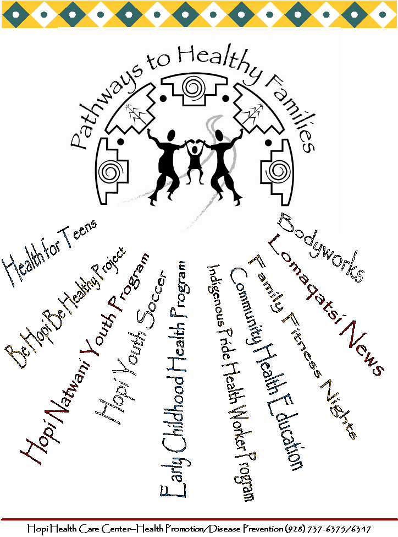

Community Health Education

- Diabetes Education
- Health & Wellness
- Sexually Transmitted Infections
- West Nile Virus
- Hanta Virus
- Teenage Pregnancy
- Influenza
- Substance Abuse
- Physical Fitness

Early Childhood Health Program
- 8-week curriculum developed to promote 5-A-Day and well-being
- Target age group is students in Head Start through 2nd grade
- Ten local Head Start Centers and elementary schools are participating
- 450 students have participated in the program since 2006
- Collaborating with the Hopi CHR to help teach the lessons

Hopi Natwani For Youth Program
- School gardening program
- Collaborating with the Hopi Cultural Preservation Office, Natwani Coalition, school teachers and community members
- Developing a resource handbook to be used by teachers and village youth centers
- Handbook will include Hopi agricultural teachings according to the ceremonial & agricultural calendar of the Hopi

Lomaqatsi School Health Newsletter
- Educating parents and families on health and nutrition
- Newsletters are given to schools every two weeks for students to take home
- Content includes information on diabetes, nutrition, exercise, flu, heart disease, automobile safety, etc.
- 8 elementary schools and 5 Head start facilities participate

Be Hopi Be Healthy Summer Camp
- Village-based camps focusing on healthy lifestyles for children
- Cultural activities including local hikes, traditional Hopi diet, benefits of healthy weight
- Invitation to all village children, but with focus on those children who are overweight or obese
- 5 villages and 114 children participated in 2007
- 3-Day camp held in collaboration with the Hopi Wildlife Program, Hopi Wellness Center and Hopi Cultural Preservation Office

Health For Teens
- 6 Lessons designed specifically for the teenage population
- Lessons include:
  - Making Healthy Choices
  - Reproductive Health
  - Who am I? (Treasure Mapping)
  - Teenage Pregnancy
  - STDs & HIV/AIDS
  - Dating Violence and Teenage Relationships

Lomaqatsi News Employee Newsletter
- A newsletter designed to educate employees about health issues
- Highlights events and activities at the Hopi Health Care Center
- Distributed on a monthly basis
- Any department or program can submit articles, photos, or events.

Fitness Rezolution, Employee Fitness/Wellness Program
- 3 month program designed to motivate employees to be physically active
- Program is run on a quarterly basis
- Fitness nights are hosted at the Hopi Health Care Center
- Noon-time presentations are given by various departments on health and well being

Housecalls Radio Show
- Hosted by Dr. Anna Lewis once a week
- “The show that is guaranteed to add ten years to your life…”
- Various health issues are discussed
- Local health professionals are interviewed on the show regarding their program, project, or specific health issue that they work on.

Hopi Youth Soccer
- Summer program for youth ages 5-12
- Volunteer coaches help coach the different age categories
- 6 week program
- Partnership with AYSO (American Youth Soccer Organization)

Indigenous Pride Health Worker Program
- 8 week summer program for high school and college students
- Focus on health professions
- Students mentor health professionals in various departments
- Students also learn college skills (resume` writing, writing a research paper)
- Students take a 2 week college course on Intro to Health Careers and earn college credit

Peach Springs Health Center and Supai Health Station

Vern Phillips, Public Health Educator
- Provides services to two reservation communities; Havasupai and Hualapai.
- Primary functions: patient education on DMII; consultation and collaboration with tribes substance abuse prevention activities, DM II activities, Elderly service prevention activities; Substance abuse & obesity prevention activities in schools; Assist & collaborate PHN prevention activities; Prevention activity in Head Start, Coordinate MNT activities.

Program Goals
- Establishing a collective vision for positive change.
- Develop and design effective prevention services.
- Implement change strategies.
- Evaluate outcomes.
- And, redesigning strategies to embed positive social norms, i.e., sobriety, family value.

Recent Activities
- PowerPoint presentation on Fatherhood for Healthy Baby Fair in Collaboration with Peach Springs PHN program and Hualapai DM Program.
- Plan, develop, and implement Sobriety event in Supai in collaboration with tribal programs.
- Develop presentation for Hualapai Elderly services.
- Implement culturally relevant prevention/intervention services in collaboration with community members.
- Develop grant application for child passenger seat.

Phoenix Service Unit

See Other Attachment

San Carlos Service Unit

Sarah Schmasow, Health Educator
Louis Lorenzo, Jr., Health Education Technician

Office of Health Education
Mission: To promote healthy lifestyles through education and preventative programs.

Objective: To collaborate with local schools, tribal health departments and other health organizations to plan, coordinate and implement education and preventative programs for patients and tribal members of all ages.

Program Activities

2007 San Carlos Wellness Conference

The 2007 wellness conference was held in downtown San Carlos and drew over 500 people. Twenty seven health information booths were registered by I.H.S., Tribal, and health departments/organizations from nearby towns and communities.

Health Promotion Information Booths

Health Information and Screening Booths were setup through out the year in both the San Carlos and Bylas communities.

Health booths were setup in public places i.e. stores, clinic lobby areas, schools, fitness centers, sidewalks, etc.

Diabetes Education Kids Camp

A five day summer camp for children ages 8-12 was implemented with assistance from I.H.S. Community Health staff and the Tribal Diabetes Prevention Program.

A total of 80 children were enlisted for both the San Carlos and Bylas communities. All campers completing the five day camp were taken to Tempe Big Surf as an incentive field trip.

Walk Against Diabetes

Program Goal: To coordinate and implement weekly community walks in November with diabetes education and prevention booths along a 4 mile walking route.

Accomplishments: Over 200 walkers participated in San Carlos and 130 in the Bylas community for the weekly walks.

Apache Men’s Health Fair

The purpose of Men’s Health Fair is to heighten the awareness of preventable health problems and encourage early detection and treatment of disease among Apache men and teen boys.

The four hour Men’s Health Fair for Apache men and teen males drew over 150 participants. The Men’s Health Fair is held in conjunction with the National Men’s Health Week which is the week prior to Father’s Day.
The 2008 Apache Men’s Health Fair is scheduled for June 12, 2008, at San Carlos Hospital.

San Carlos Youth Conference

Project Goal: To implement education and preventative services for over 500 high school and junior high students on substance abuse, methamphetamine, diabetes, fitness, teen pregnancy, etc.
Conference topics also included leadership, character & life skills development, and educational & career development.

Fire Safety & Prevention Week

Project Goal: To implement Fire Safety and Preventative activities for all schools (grades Head Start to Junior High) in both the San Carlos and Bylas communities.

Red Ribbon Campaign Week

Our goal this year was to target students in Junior High with substance abuse and peer pressure prevention/education.
The week long activities also included a community awareness parade, walk and luncheon. The activities were held in collaboration with all local schools and tribal health programs.

Youth Fitness & Sports Program

Project Goal: To implement preventative and educational activities for local youth through fitness and sports activities during the spring, summer, and Christmas holiday breaks (from school).

Other Health Education Activities

- Support the San Carlos STEPP Initiative; including its four district Anti-meth coalitions
- Prenatal Car Seat Classes (monthly)
- Seat Belt Initiative Checkpoints (Quarterly)
- Community/School Health Fairs (April)
- Community Spay & Neuter Clinic (June)
- Children’s Dental Health Month (February)
- AIDS/HIV Awareness Campaign (December)
- Alcohol Awareness Month (December)
- Flu Prevention/Education Campaign
- Child Abuse Prevention Month (April)
- Nutrition Adventures for Kids (March)
- Co-sponsored the Apache Meth Summit
- Health Education Committee Retreat (January)
- Co-sponsored the Motor Vehicle Injury Prevention Conference
- Co-sponsor Fitness Challenges (Quarterly)
- SCSU Wickiup Newsletter (Quarterly)
- Hospital Week Activities (May)

