
Letter
Central Oklahoma American Indian Health Council
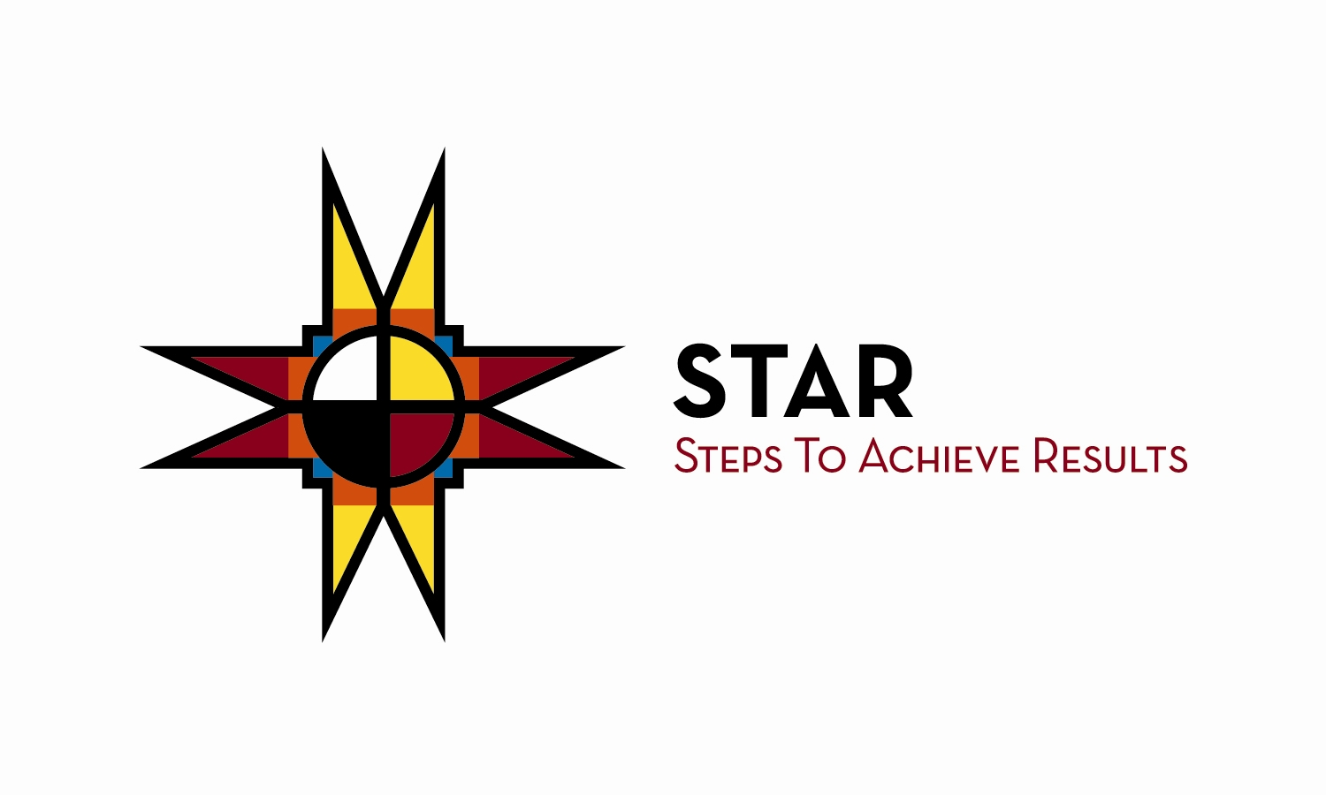
In an effort to help you create a healthy lifestyle and prevent diabetes, your medical provider has referred you to be a part of our Steps to Achieve Results diabetes prevention group. A healthier lifestyle will give you a longer life and can delay or PREVENT diabetes. This program with group education meetings, individual sessions with lifestyle coaches, fitness experts and nutritionist is exciting, educational and fun.

We have put together our fall schedule and would love for you to be a part of our next 16 week sessions. The new class is scheduled to begin on:

Tuesday, September 11 at 5:30 p.m. – taught by Carla Neal
Wednesday, September 12 at 11 a.m. – taught by Wes Wilson
Classes meet the same day and time each week for 16 weeks.

All classes will be held at our NEW location:
5208 West Reno at the Corner of Ann Arbor and Reno Avenue in suite 294.

I will be hosting an information session August 22 at 1pm and August 29 at 6pm. If you are interested in either of these classes this would be the perfect time for you to come and learn more about our life changing program. Please call me with any questions at ext. 280.

Here’s to your health!

Susan Starr
Diabetes Prevention Data Coordinator/Recruiter
Oklahoma City Indian Clinic
4913 West Reno
Oklahoma City, OK 73127
(405) 948-4900 ext. 280
www.okcic.com

