ABC’S OF DIABETES CARE:
ABC’s of Diabetes Care
Sault Ste Marie Chippewa

A1C  At least twice each year |  |  |  | My goal: ______
Date
Result
Blood Pressure (BP)  At each visit |  |  |  | My goal: ______
Date
Result
Cholesterol  Once each year |  |  |  | My goal: ______
Date
Result

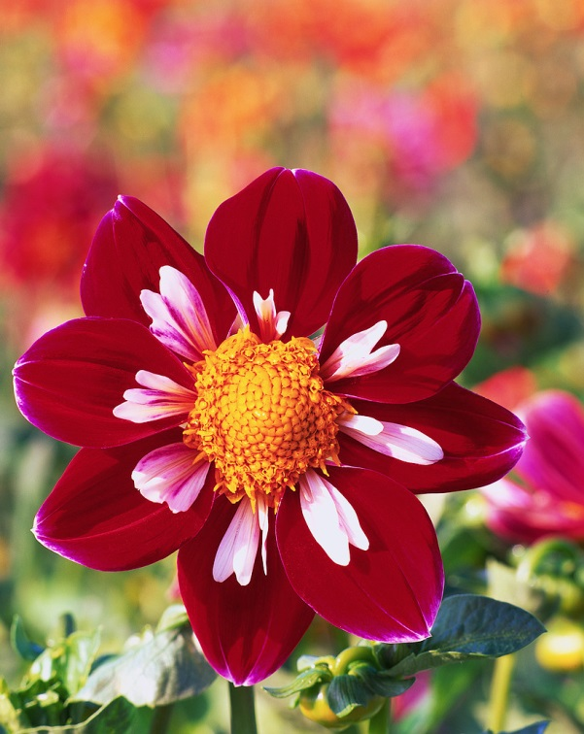

MY DIABETES CARE RECORD
Each Visit | Date | Result
Foot check
Review self-care plan
Weight check
Review medicines
Once a Year | Date | Result
Dental exam
Dilated eye exam
Complete foot exam
Flu shot
Registered Dietitian visits
Kidney check
At least once | Date | Result
Pneumonia shot
Hepatitis B shot

