12 best fiber foods
Albuquerque Service Unit
12 Best Fiber Foods

Why do we need Fiber? A high fiber diet has been shown to lower blood cholesterol levels, prevent constipation and decrease the risk of heart disease. High-fiber foods also tend to contain more nutrients and fewer calories, are digested more slowly, and help us feel full sooner. A dark colored fruit or vegetable has disease-fighting chemicals.
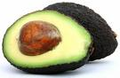
Most nutrition experts recommend 25-35 grams of fiber per day.
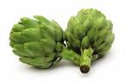
- Avocado – 1 medium avocado has 8.5 grams of fiber. It is also Loaded with 20 vitamins and minerals.
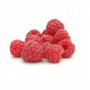
- Artichoke – 1 medium=6.5 grams of fiber. Provides a good amount of Vitamin C, folate, potassium and magnesium.
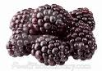
- Raspberries –1 cup =8.4 grams of fiber. High in Vitamin C and other nutrients.
- Blackberries – 1 cup=8.7 grams of fiber. Improves health and fight disease.
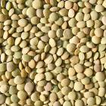
- Lentils – ½ cup = 8 grams of fiber. Great source of protein. Contains saponins, which may help lower cholesterol and blood glucose levels.
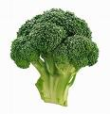
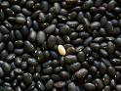
- Black Beans – ½ cup = 7 grams of fiber. Same benefits as lentils. All beans have about the same amount of fiber and protein.
- Broccoli – 1 cup = 6 grams of fiber. Known to have anti-cancer properties and body benefits.
- Vegetable Beef Soup – 1 cup of Low Sodium Chunky Vegetable Beef Soup = 6 grams of fiber, 14 grams of protein & 50 grams of sodium.
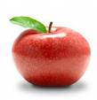
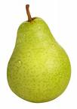
- Pear – 1 medium=4.5 grams of fiber. The skin is important too.
- Apple –1 medium=4 grams of fiber. Eat the skin too. The skin has several nutrients.

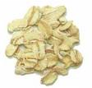
- Oatmeal- 1 cup = 4 grams of fiber. Use old- fashioned rolled oat or steel-cut oats for the best health bang for your buck.
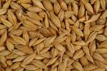
- Barley – ½ cup = 3 grams of fiber. Look for less processed, “hull-less” barley. More fiber and blood sugar protection.

