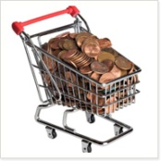
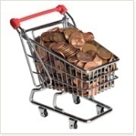
20 Ways to Eat Healthy on a Budget
Eat healthy on a budget
Ponca Tribe of Nebraska

1. Buy Whole Foods. Unprocessed foods are often cheaper and more nutritious than processed foods. They also give you total control over the ingredients. Try to avoid or eat less of anything that comes from a box. Limit extras like sodas, alcohol, candy, gum, and chips, which have very little or no nutritional value.
- Whole Food Examples. Ground beef, chicken breast, cottage cheese, plain yogurt, eggs, milk, pasta, rice, oats, potatoes, beans, apples, bananas, raisins, broccoli, spinach, cabbage, olive oil, fish oil, flax seeds, and nuts.
2. Purchase Cheap Proteins. Plan your menus around meats on sale. Keep the steaks & salmon for special occasions, as they are usually more expensive. Beans, soy, and eggs are usually less expensive than meats, so go vegetarian a couple of meals a week. Other good sources of protein are milk, whey, canned tuna, cottage cheese, and Greek yogurt.
3. Buy Frozen Fruits & Veggies. Unfreeze berries in microwave and eat warm with cottage cheese. Try frozen vegetables and add your own sauce or seasoning. Benefits:
- Save Money. Often half the price of fresh. Longer shelf life when kept in freezer, which allows you to buy in bulk to get more of a discount.
- Nutrient Dense. If frozen right when picked, frozen fruits and veggies can contain more nutrients than fresh ones.
4. Buy Store Brands. Store brands are often comparable in nutrition to name brands and usually taste just as good. Plus they usually cost less, but not always, so make sure to still compare prices with brand names. Store brands tend to be positioned on the top and bottom shelves.

5. Avoid Wasting Food. Your vegetables in the crisper drawer spoiled before you could make that casserole. Does this situation sound familiar? It probably does. If so, store fruits and vegetables in the refrigerator at eye level. That way you will be less likely to forget about them and have to throw them away. Also, leftovers are vital. Use last night’s baked chicken breasts for tonight’s chicken noodle casserole.
6. Buy in Bulk. Especially when the items are on sale. If they're on sale, buy as much as you can afford & store to last you until the next sale. Foods like pasta, rice, oats, and frozen and canned goods are easy to stockpile. Be sure to also check out your local supermarket’s bulk bins as well; food items in bulk bins are often less expensive than packaged foods.
7. Buy In Season. Fruits and veggies grown in season taste better and cost less. Buy root vegetables in the winter. Apples & squash in the fall. Broccoli & berries in the summer. Some supermarkets even have signs up in the produce section showing what’s in season when. Watch the weekly ads, too.

8. Small Scale Experiments. When trying a new food, buy the smallest size of package. That way, if your family doesn’t like the food, you’re not stuck with a big box. Also, check preparation methods for unfamiliar foods. Sometimes foods look enticing in the store, but when you get home, you’re not sure what to do with it. You may have to do a little research to avoid this situation. Ask the grocery store clerk, look online, or find a cookbook for some insight.
9. Buy Discounted Meat. Grocery stores often discount meats by up to 70% as they approach expiration date. What you don’t use fresh you can store in your freezer. Raw ground meat maintains optimum quality in the freezer for 3 to 4 months. Larger pieces of meat like steaks or chops maintain optimum quality for 4 to 12 months. Remember to watch the weekly ads for sales, too.
10. Buy From Local Farmers. Farmer’s markets are a great source of fresh produce. They aren't always cheaper, but you get tastier & better quality food while supporting your local farmers. Fruit and vegetable stands are also sometimes a better deal.
11. Buy Everything from One Place. Time is money and fuel is expensive. Stop shopping for sales going to 10 different places. Find 1 or 2 places that get you cheap prices for most foods you need and buy everything there.
12. Drink Tap Water. Get a water-filtering pitcher and filter your tap water. It's cheaper than bottled water, soda or juice. One $8 filter cleans 40 gallons of water and makes it taste a lot better.
13. Clip Coupons. Invest a couple bucks in your Sunday paper or print the coupons from an online source. Grocery receipts often have coupons on the back, too. Only use coupons for foods you would normally eat, though; buying new items just because there is a coupon may lead to unwanted food waste.
14. Get The Customer Card. Many grocery stores hold sales for customer card holders only. Some cards save AND give you money, like gift certificates once you've spent a fixed amount. Signing up only takes a few minutes and it’s free.
15. Check the Unit Price. The unit price is the price per pound or ounce. Most stores have unit price labels on the shelves. Bigger packages are often, but not always cheaper than smaller ones. Sometimes 2 small boxes are cheaper than 1 big one, although there's more packaging. Buy the size that fits your budget and meal plan.

16. Avoid Convenience Foods. You probably are only saving a few minutes by not cutting up those vegetables or fruits, but stores often add a hefty labor cost to pre-cut or pre-made items. Instead, try cutting/prepping foods yourself to save some extra cash.
17. Make a Grocery List and Stick to It. Failing to plan is planning to fail. The best way to avoid impulse buying is to prepare yourself before going shopping. Plan your meals ahead, including portion size. Make a list of all foods you need for the next 7 to 14 days. Go to the grocery store, get what's on your list and get out. Also:
- Eat Before You Go Shopping. This prevents buying foods not on your list because you're hungry.. Eating before shopping not only helps avoid impulse buys, but it may also save calories.
- Shop Alone. Prevents impulse buying from wife/husband and/or kids. Leave them home.
18. Stop Buying Food Outside. Preparing your own food gives you total control over the ingredients and is often less expensive than buying food at work/school.
- Take Food with You. Food containers for work/school, protein shake for the gym, bag of nuts when you go to the movies, etc.
- Eat Before Leaving Home. Eat breakfast, eat before grocery shopping, eat before going out with friends/family, etc.
19. Keep it simple. Purchase processed foods less often. Make homemade granola bars, homemade tomato sauce, homemade pizza…possibilities are endless. Learn to cook from scratch and work with spices & herbs. Take a cooking class at a local community college. Watch cooking shows on TV. Experiment with new recipes.
20. Grow Your Own Food. This is cheaper than buying frozen, tastes better and you control what you put on them to keep bugs off. Plant your own trees that grow berries, walnuts, apples, etc. Buy chickens for free eggs & meat. Vegetable gardens can also help save money:
- Square-Foot Gardening. Build a raised bed and divide it into sections of 1 square foot.
- Container Gardening. Grow vegetables in containers on your balcony or doorstep.
- Community Garden: Community gardens provide fresh produce and plants as well as satisfying labor, neighborhood improvement, sense of community and connection to the environment. They also improve users’ health through increased fresh vegetable consumption and providing a venue for exercise.

Homemade Chicken Enchiladas vs. Fast Food Chicken and Potato Burrito

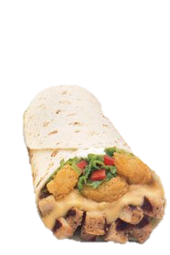
Chicken & Potato Burrito, Medium Potato Ole, Medium Coke
Calories= 1370
Calories from fat=540
Total fat (g)= 59
Saturated fat (g)= 15
Trans fat (g)= 0
Cholesterol (mg) =35
Carbohydrate (g)= 185
Fiber (g) =12
Sugar (g) =59
Protein (g) =25
Sodium (mg) =3530
$Cost
VS
2 Enchilada’s, ½ cup fruit, water $Cost
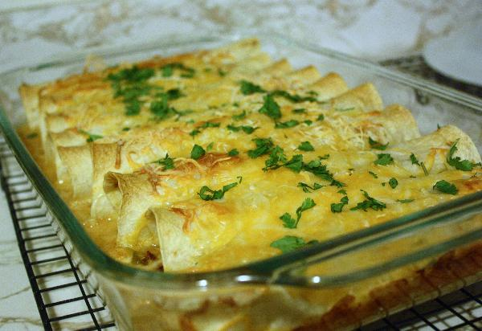
Calories=350
Calories from fat= 144
Total fat (g)= 16
Saturated fat (g)= 0
Trans fat (g)= 0
Cholesterol (mg)= 20
Carbohydrate (g)=34
Fiber (g)= 3
Sugar (g)= 0
Protein (g)= 19
Sodium (mg)= 260

Nutrient info from tacojohns.com & calorieking.com

Chicken Enchiladas
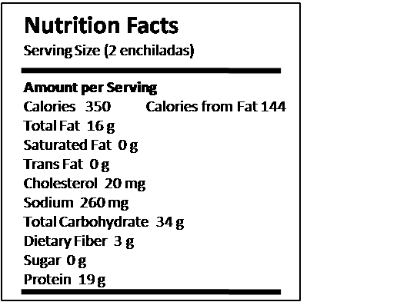
Source of recipe and photo: extension.org Quick and Healthy Recipes
Total Servings (Yield): 8 servings
Serving Size: 2 enchiladas
Ingredients:

- 3 boneless, skinless chicken breasts with visible fat removed
- 2 green bell peppers, cut into strips
- 1/2 large onion, sliced
- 1 tablespoons olive oil
- 1 1/2 (10 ounce) cans enchilada sauce
- 1 1/2 cups reduced fat Mexican Blend shredded cheese
- 16 (6 inch) corn tortillas

Directions:

- Preheat oven to 350°.
- Bake chicken for 20 minutes (or until done).
- While chicken is cooking, sauté onion and pepper in olive oil.
- Cut chicken into strips.
- In a bowl, combine 1/2 can enchilada sauce, chicken, onion, pepper, and 1/2 cup cheese.
- Place a spoonful of chicken mixture into center of a corn tortilla and wrap. Place in a 9 by 13 inch baking dish.
- Repeat with remaining mixture and corn tortillas.
- Top with 1 can enchilada sauce and remaining cheese.
- Bake at 350° for 10 minutes or until cheese melts.

Can add stuff from Alice Henneman email Fw: Quick & Healthy Recipe and Tip of the Month‏

September can be a hectic time if you have children going back to school and you are trying to schedule your evening meals around their activity schedule. You can manage by planning to have meals you can pop in the oven when you walk through the door.
http://www.quickhealthyrecipes.msstate.edu/view_recipe.php?recipe=39&value=corn
Questions for Discussion
- What are some things you do to save money when buying healthy food?
- What are other resources for food besides grocery store?
  - Farmer’s markets
  - Food banks
  - Gardens
  - Home-raised animals
  - Commodity and other food assistance programs
  - Community events
  - Hunting/fishing/gathering
  - Restaurants
- What are some healthy foods that we can buy and prepare?

