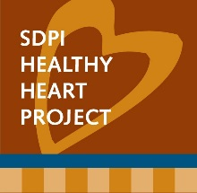
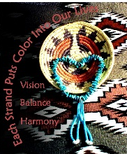
Letter of Invitation to “Song & Dance” Event
Ramah Navajo School Board
May 19, 2008

To Whom It May Concern:

This letter describes the efforts of the Ramah Navajo Song & Dance Committee and the activity it has planned for this summer at Pine Hill. The Song & Dance is part of our diabetes awareness and outreach program known locally as the Heart Saver Project. It is under the auspices of the Pine Hill Health Center as part of a large competitive grant from the Indian Health Service Special Diabetes Program for Indians. The goal of the Heart Saver Project is to prevent heart disease and increase awareness about diabetes and its complications.

The Song & Dance is a traditional Navajo social dance in which all attendees are encouraged to participate. Because traditional dancing is a form of physical activity, we are encouraging our community members to participate. In between dances (which are separate songs by drum and singing groups) there is ample opportunity for the announcers to provide health education by offering little encouragements to the attendees about healthy lifestyles, including eating well and getting active. During the intermissions we will provide games for the attendees as fun ways to learn about nutrition and exercise. By both dancing and learning we believe the Song & Dance activities are helping our community to prevent the onset of diabetes and to reduce its complications.

Thank you.

Sincerely,

Carolyn E. Finster
Clinic Administrator
Acting Division Director
Health & Human Services

