How to EARN your new Healthy Lifestyle
Punch Card
Ponca Tribe of Nebraska
One Punch for each of the following:
**Each case management visit
**Physical with physician
**Dental appointment
**Eye appointment
**EKG completed
**Foot exam
**Point for each Gift of Heart Health class completed (10)
**Attendance to Health sponsored Pow wow’s or Health Fairs
(max of 2 points for these events)
**Attaining exercise goals set each month
**Weight loss of at least 2% every 3 months
**Lowering of B/P after 6 months
**Improving 2 of the 4 components of high cholesterol @ 1 yr:
*Total cholesterol *LDL *HDL *Triglycerides
**Lowering of A1c after 6 months
**Yearly flu vaccine
Each card will contain 15 punches.
You may complete a card and turn it in
OR save up for a larger incentive!!!

**Please note incentives are based upon eligibility and may be substituted for a product of same value.
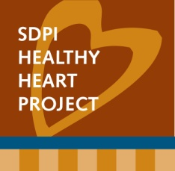

SDPI HH Incentive Punch Card

This card belongs to: _________________________________________

SDPI HH Incentive Punch Card

This card belongs to: _________________________________________

